Instructions
The Capsule Machine Liquid Filling Accessory

The liquid filling accessory kit includes Drying Rack, Sealing Solution (6 ounces), dropper, silicone brush, and ejection pusher. Seals and dries 24 capsules at a time. The heated solution goes in the top of the capsules and then the 24 capsules are joined. The solution solidifies at room temperature, preventing leakage of the liquid. Additional individual parts and Sealing Solution refills are also available for purchase. Not for use with liquids containing water.

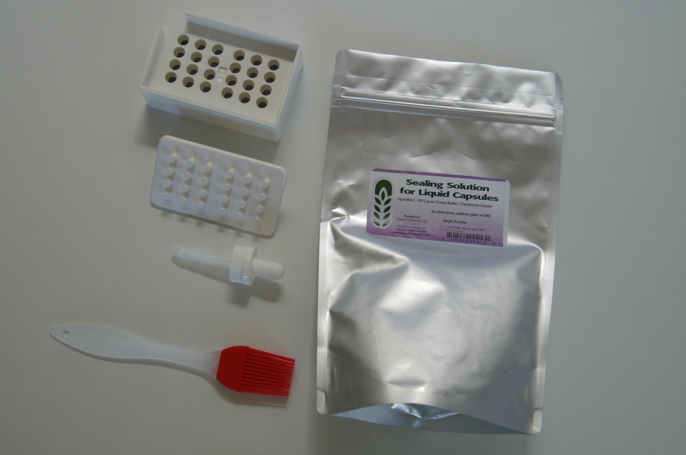
Clean all parts well before using and make sure they are completely dry.

1. Read green sheet that came in the desiccant bag that was packed with The Capsule Machine. Put base on stand with wide part of stand on top. Put longer part of capsule (body) in base, shorter part of the capsule (cap) in top) open ends out.
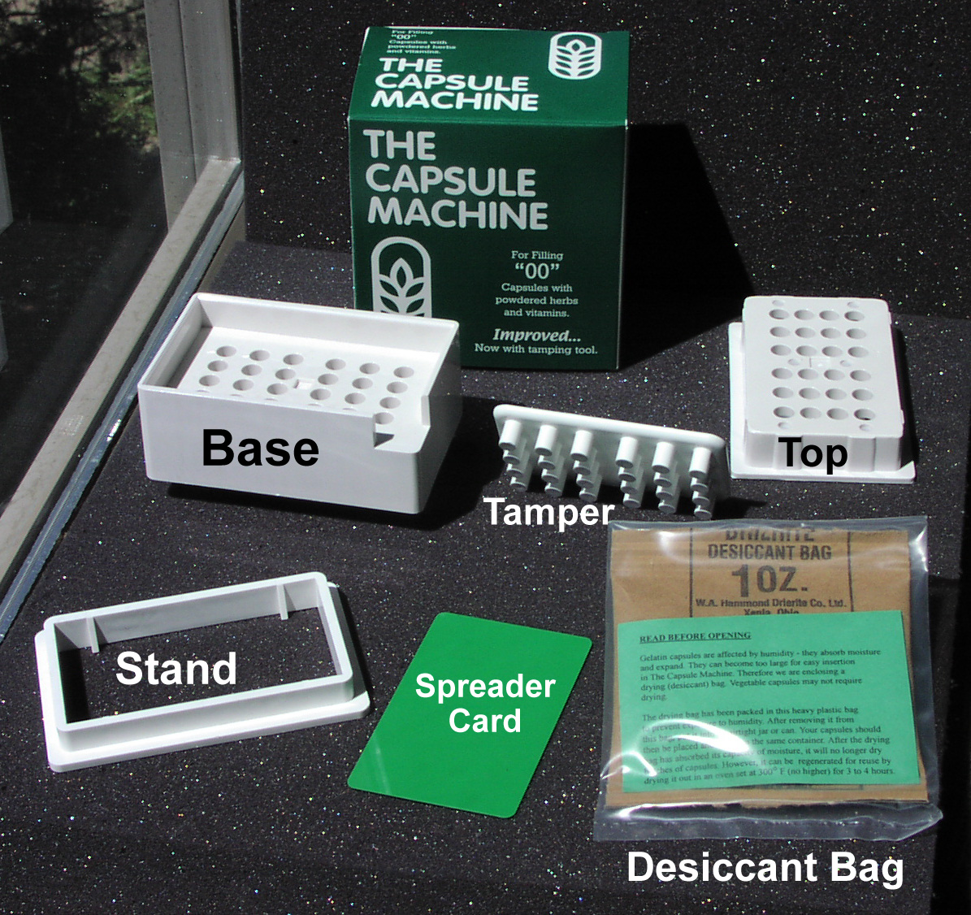

2. Using dropper, fill the bodies about 80% full. The capacity of the “0” size is .68 ml, so put in about .5 ml. The capacity of the “00” size is .91 ml, so put in about .7 ml.
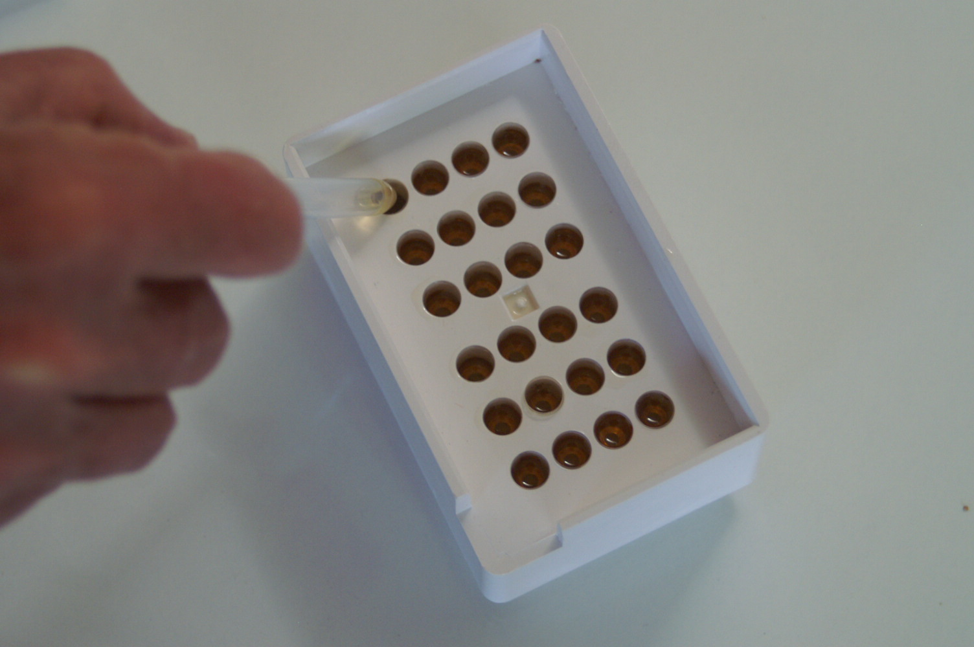

3. Heat Sealing Solution to about 90 to 110 degrees F. until liquid. Don’t overheat or the solution may melt the capsules. Use a bowl with a flat bottom and pour in Sealing Solution about 1/8 inch deep.
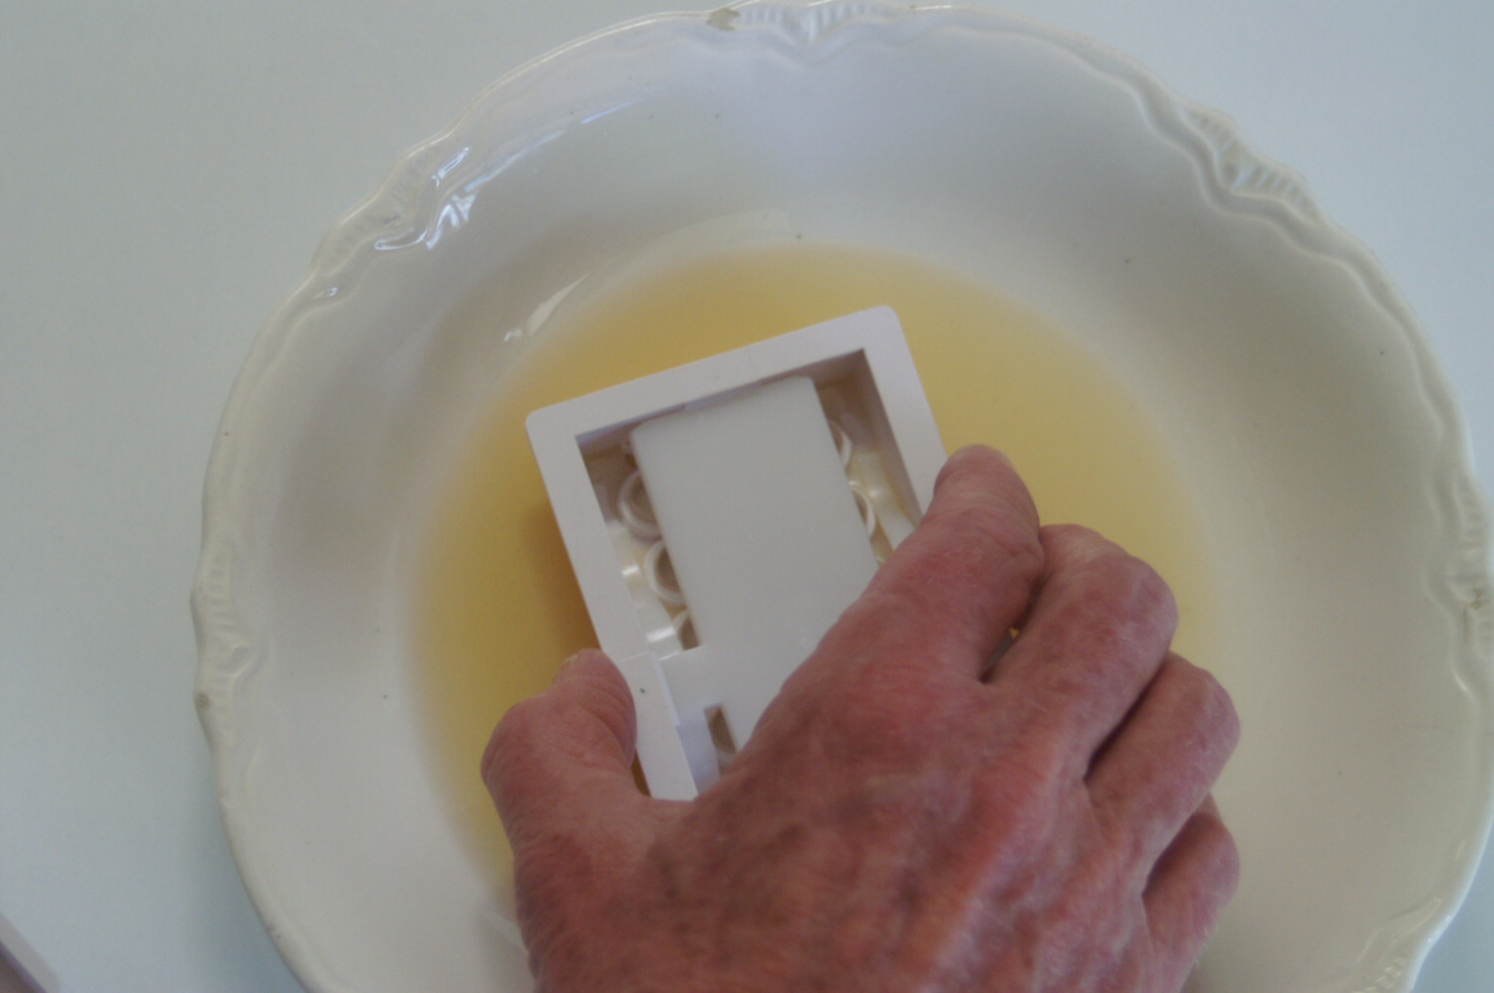

4. Insert the Capsule Machine top into the solution. Slowly pull the top out of the solution and wait a few seconds if dripping. Do not turn the top over. Raise it above your head and use silicone brush to wipe excess solution back and forth and up and down off of the plastic into the holes.
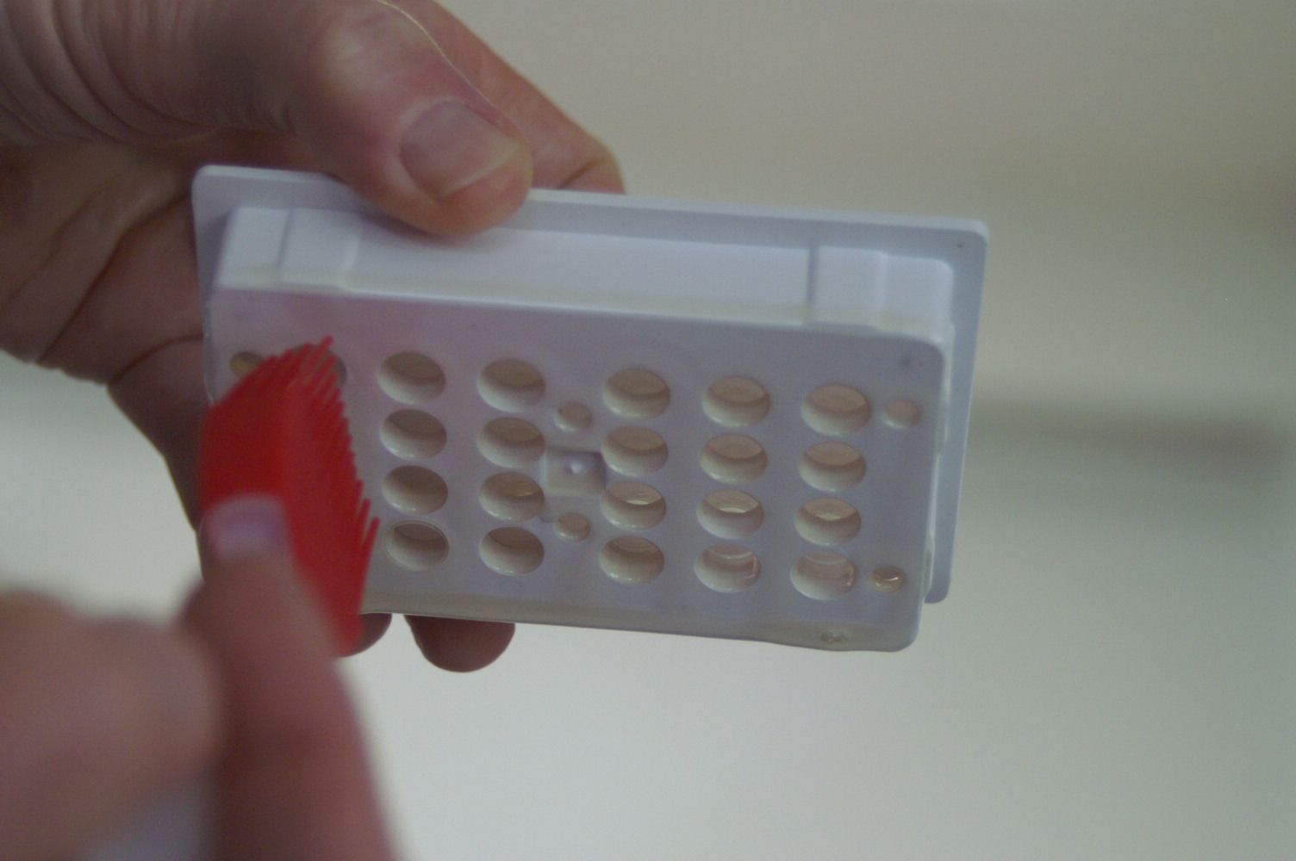

5. Take the base off the stand. Put on the top. Put on flat surface. Press down firmly on sides until unit bottoms out. Filled capsules are automatically joined and held in top.
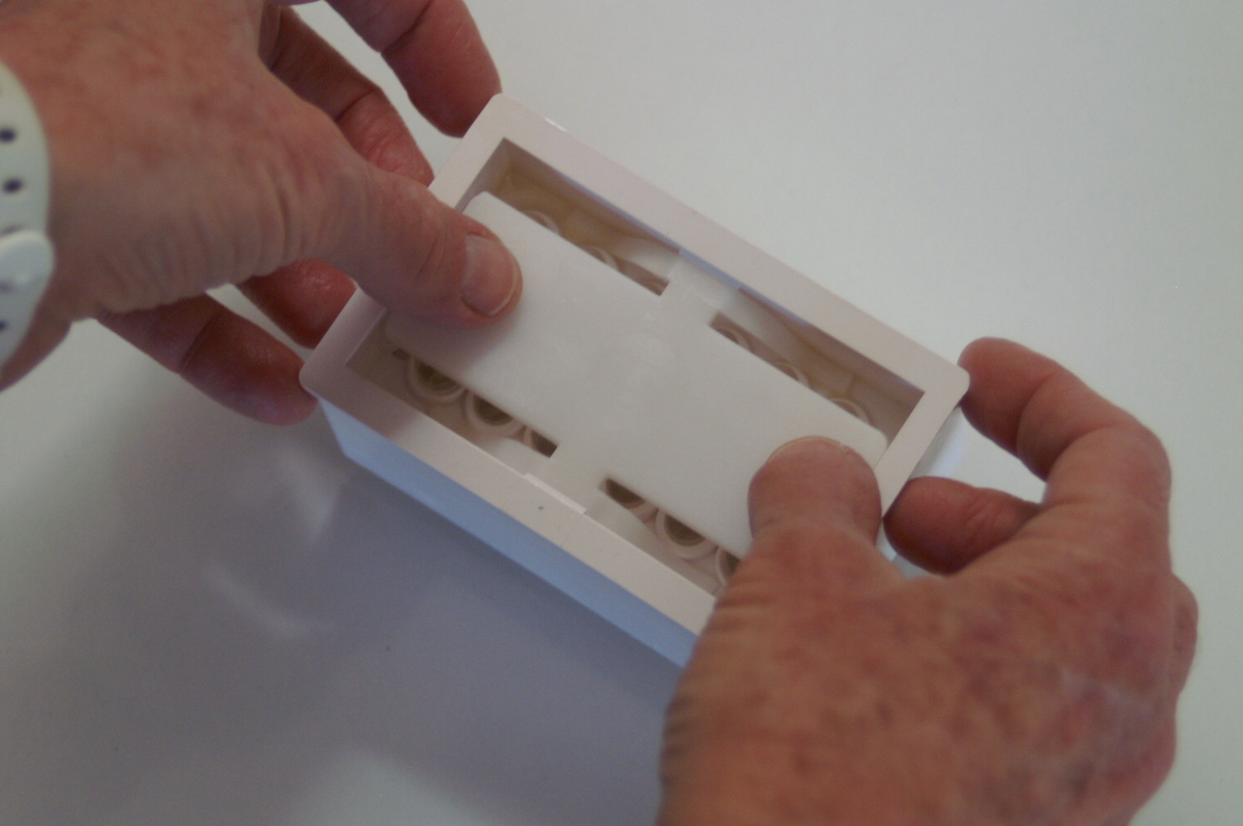

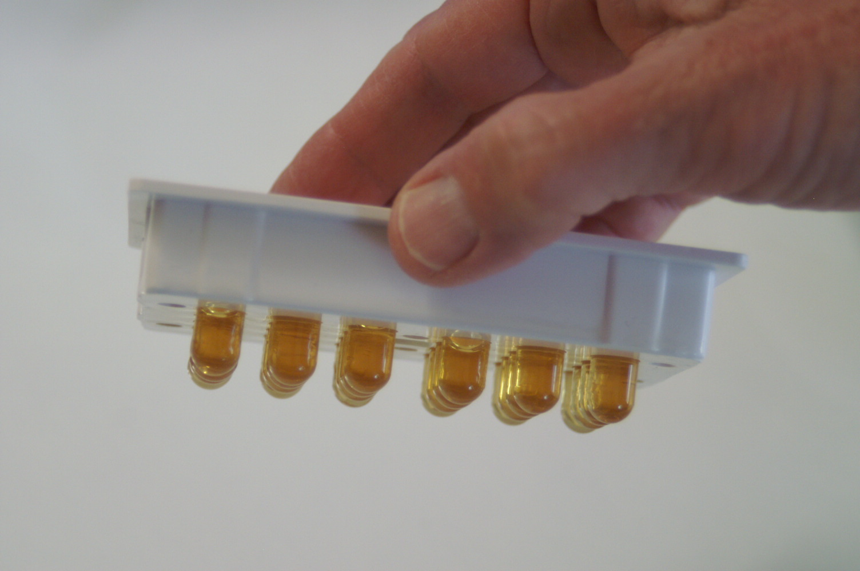
6. Align top over drying rack, with the bottom of the Capsule Machine top just below the top of the vertical lip of the drying rack. Press down with both thumbs on the top spring evenly and firmly. Capsules are ejected into rack.
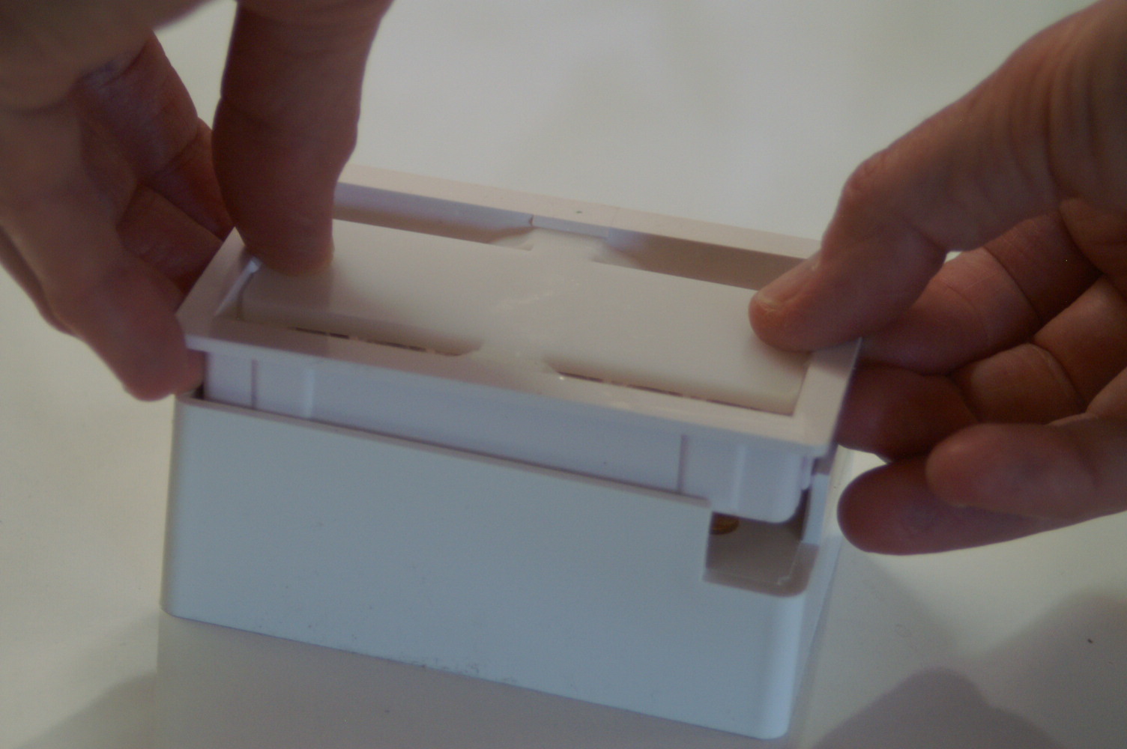

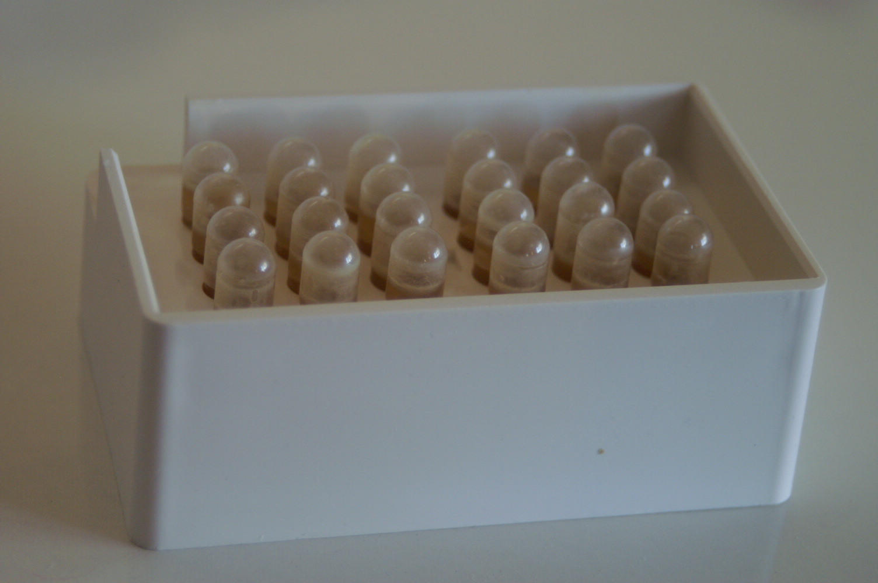

7. Allow capsules to dry for one day. Better and faster results may be obtained if you put the drying rack into a refrigerator promptly. After Sealing Solution is dry, turn drying rack upside down to eject all the capsules. If the capsules are stuck, you should use the ejection pusher to get the capsules out (below). Store filled capsules (preferably in a vertical position) in a cool place (refrigerator OK).
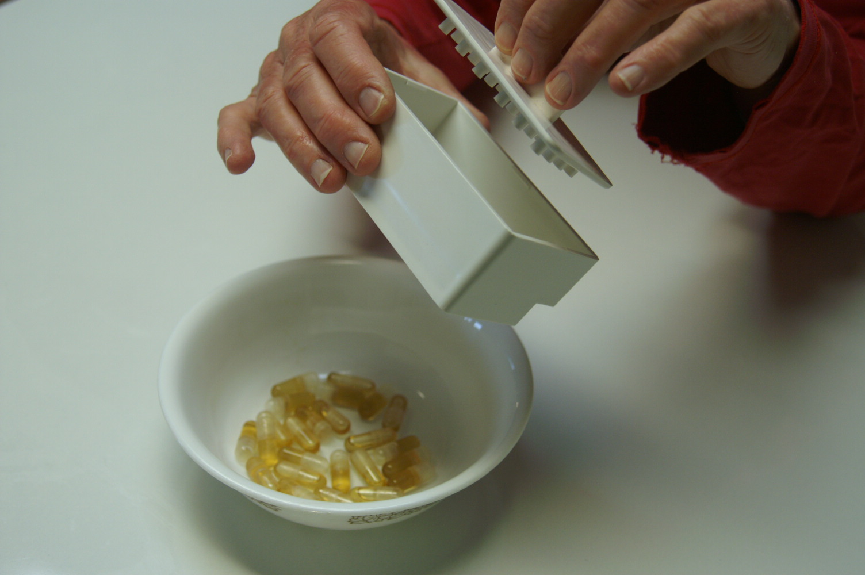

8. Wipe excess Sealing Solution from the Capsule Machine top. Repeat for additional batches. If you aren’t filling more capsules within an hour, make sure you remove all Sealing Solution by promptly washing all parts in hot soapy water or on the top shelf of a dishwasher. Make sure the Capsule Machine and parts are dry before use. Any water could break down the capsules.

Note that some adhesive may float in the oil inside the capsule. This is normal.

The kit works well for “0” and “00” sizes. It may work for #1 size.
Sealing Solution is 100% Pure Food Grade Cacao Seed Butter.

The Sealing Solution and Drying Rack will work for people who do not have a Capsule Machine.
In that case, you will need to manually dip each capsule top into the Solution and join, and then put in the drying rack.

